Date: 23/01/2018

Sales Quotation

NIHVA TECHNOLOGIES PVT. LTD.
187, G-Block, Thermax chowk, Above Renault Showroom, MIDC
Chinchwad, Pune – 411019.

Customer Name | DEV TECHNOSKILLS
Project Name | AMAR TEA PLANTATION PVT LTD
Project Location | Mumbai
Contact Person Name | Mr. Devang Parikh
Email Id | Devang@devtechnoskills.co.in
Contact Number | 9819351217

Contact Person: Mr. Mayur Derle
Mob No.: 7709209333
Email id: automation@nihva.com
Web: http://www.nihva.com

Quotation No: SQT/17-18/0001

Subject: Automation for Society Tea Packaging for 5 kg bag

Dear Sir,

Thank you for the opportunity and trust shown on “NIHVA” your preferred partner for innovative solutions. This has reference to your above-mentioned requirements as well as our subsequent communication; please find below our best offer.

Process flow for 5 kg Tea Bag: (Line 1)
Collating

BOPP Taping/Hot glue

Client Scope
Filling Line & take off conveyor
Roller Flattening

Tertiary Carton

Check Weightier with reject

Pick & Place
OR
Dumping in
Flattening

Case Erector & conveyor

Barcode generation
On Sticker & Sticking

Online weighing with reject

Printing Provision on carton

Auto Scanning

Palletising

Scanning of pallets (RFID) & Marrying each box (Barcode

Loading on Conveyor to FG

Details
Pack Size(mm) | 280 L x 550 H x 120 G
Pouch Style | Side Gazetted Penta seal (Centre seal) pouch with Euro carry handle punch
Pouches/shipper (No.s) | 4
Kg/Shipper | 20 kg
Shipper Size | 630 L x 380 W x 270H
Shipper Type | 5 Ply
Shipper packing  Configuration | 2 x 1 x 2 (L x W x H)
No. of machines | 1
Machine output | 20
Product Details: - (For 5 kg Tea Bag)
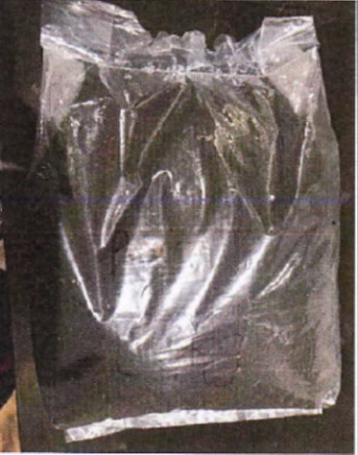

Technical Specifications: - (For 5 kg Tea Bag)
Sr No. | Packaging System Description | QTY
1 | Roller Flattening Conveyor |  | 1
 | • Conveyor Width | 400 mm
 | • Conveyor Length | 1000 mm
 | • Construction | MS Powder Coated
 | • Contact Parts | SS304
 | • SKID PLATE | SS304
 | • Motor | Bonfiglioli with Gear
2 | Check Weigher & Rejector with Conveyor |  | 1
 | • Make | Technofour Electronics
 | • Model | CW1200
 | • Display | Graphic LCD
 | • Maximum weight | 5 kg
 | • Weighing Scale | upto 5 kg
 | • Accuracy | is + /- 50 gms
 | • Conveyor Belt | Belt Type
 | • Conveyor Belt Width | 400 mm
 | • Speed | 20 Pouch/min
 | • Sensor | Load Cell
 | • Material of construction | MS Powder Coated
 | • Rejection Mechanism | Conveyor Stoppage/Pneumatic Pusher Type
 | • Power Consumption | approx. 350 VA
3 | Collating Conveyor |  | 1
 | • Conveyor Length | 1200 mm
 | • Construction | MS Powder Coated
 | • Contact Parts | SS304
 | • Motor | Bonfiglioli with Gear
4 | Automatic Carton Erector Machine |  | 1
 | • Production speed | 12 cartons/min
 | • Carton size(mm) | 630 L x 380 W x 270H
 | • Power supply | 110/220V50/60HZ 1Phase 200W
 | • Air Compressing | 6kg/cm³
 | • Adhesive tape width | 48/60/75MM
 | • Machine dimension | L2000xW1900xH1450mm
 | • Machine weight | 450 Kgs
 | • Motor | Bonfiglioli with Gear
5 | Gravity Cartons |  | 1
6 | Cylindrical Operation |  | 1
 | • Conveyor Width | 300 mm
 | • Conveyor Conveyor | 1500 mm
 | • Belt | Food Grade PVC
 | • Gear Motor | 0.25HP
 | • Speed Control | Speed Control through VFD
 | • Pick and Place | 3 Axis Servo Pick and Place machine
 | • Speed | Upto 9 Cycles per min
 | • Loading Station | 1
 | • Dropping Station | 3 or 4
 | • Motor | Mitsubishi servo motor with Gearbox
7 | Vibro Flatteners for Cartons |  | 1
 | • Motor | Bonfiglioli with Gear
8 | Automatic Carton Sealer (BOPP Tapping) |  | 1
 | • Carton Size | 630 L x 380 W x 270H
 | • Sealing Capacity | About 1000 Standard Case Per Hour
 | • Adhesive Tape Used | BOPP Self Adhesive Tape
 | • Power Sources | 220 V, 50 Hz, 250w
 | • Max Sealing Dimensions { W X H } | 500mm X 600mm
 | •Min. Sealing Dimension { W X H } | 680+-100 mm
 | • Motor | Bonfiglioli with Gear
9 | Barcode Genarator , Sticking |  | 1
10 | Check Weigher & Rejector Machine |  | 1
 | • Make | Technofour Electronics
 | • Display | Graphic LCD
 | • Maximum weight | 20 kg
 | • Weighing Scale | 0-20 kgs.
 | • Accuracy | is + /- 0.2 kg
 | • Conveyor Belt | Roller Type
 | • Conveyor Belt Width | 500 mm
 | • Speed | 5 Boxes/min
 | • Sensor | Load Cell
 | • Material of construction | MS Powder Coated
 | • Rejection Mechanism | Conveyor Stoppage/Pneumatic Pusher Type
 | • Power Consumption | approx. 350 VA
10 | Printing Provision On Cartons |  | 1
 | • Brand | Domino
 | • Max line speed (SL 5x5) | 325m/min
 | • IP Rating | IP55
 | • Operating Temp | 5-45 deg c
 | • Power Requirement | 100-240 V, 50-60Hz
 | • Weight | 24.5 kgs.
11 | Scanning & Monitoring |  | 1
 | • Brand | Motorola
12 | Palletization for Carton with Scanning RFID & Barcode |  | 1

Images : -
1. Roller Flattening Conveyor 2. Check Weather & Rejecter Machine



3. Automatic Carton Sealer M/c 4. Barcode Generator & Sticking m/c
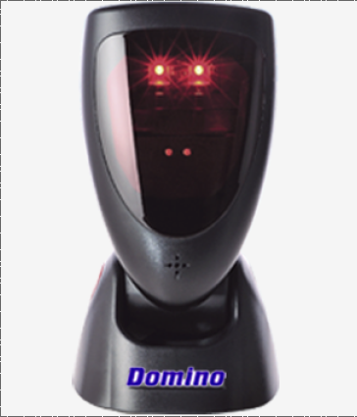


3. Printing Machine 3. Scanners
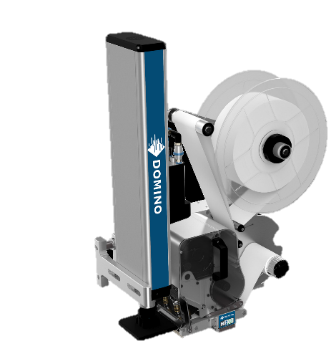
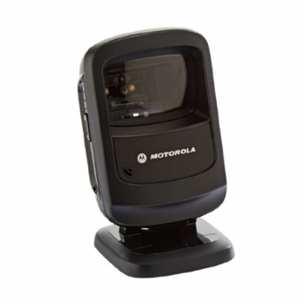

Pricing : -
Sr No. | Description |  |  |  | Qty | Unit | Rate IN INR | Net Amount
1 | Roller Flattening Machine |  |  |  | 1 | No | 1,50,000 | 1,50,000
2 | Check Weigher & Rejecter Machine |  |  |  | 1 | No
3 | Collating Machine |  |  |  | 1 | No | 3,00,000 | 3,00,000
4 | Carton Erector Machine & Conveyor |  |  |  | 1 | No | 10,00,000 | 10,00,000
5 | Gravity Carton/cylindrical operation |  |  |  | 1 | No | 1,00,000 | 1,00,000
6 | Vibro Flattening |  |  |  | 1 | No | 1,50,000 | 1,50,000
7 | Automatic Carton Sealer Machine |  |  |  | 1 | No | 3,50,000 | 3,50,000
8 | Barcode Reading /sticking/Generation |  |  |  | 1 | No | 9,00,000 | 9,00,000
9 | Check Weigher & Rejecter Machine |  |  |  | 1 | No
10 | Printing Provision For Cartons |  |  |  | 1 | No | 4,50,000 | 4,50,000
11 | Scanning & Monitoring |  |  |  | 1 | No | 2,00,000 | 2,00,000
12 | Palletization |  |  |  | 1 | No | 8,00,000 | 8,00,000
 | Total Amount |  |  |  |  |  |  | 44,00,000
 | Amount In Words |  |  |  |  | Rupees Fourty Four Lacs Only

G. Terms and Conditions: -

- Price : Ex. Works Pune

- P & F : 3 % Extra at the time of delivery.

- Freight Notes : Extra as applicable.

- Delivery : Within 9- 10 weeks from date of receipt of
confirmed purchase order, advance payment,
drawing approval.

- Payment Terms : 80% advance along with confirmed purchase
order balance before dispatch.

- Insurance : Extra as applicable.

- GST : Extra as applicable on total supply value.

- Validity : 15 days from date of quotation.

9.Warranty : 12 months from date of supply.

Please feel free to contact Mr. Mayur Derle on 7709209333 for any further clarification in this concern.

With Best Regards,
Pooja Badre
7709209333
For NIHVA Technologies Pvt Ltd

